User

Manual

**Version 2**

|  |  |
| --- | --- |
| ***Corporate Office*** | ***Offshore Development Center*** |
| *1 Pickering Street*  *#06-03 Great Eastern Centre*  *Singapore 048659* | *Plot # 122 & 123, N.S.E.Z, Phase -2*  *NOIDA, UP 201 305*  *India*  *Tel: 91.11.91.2510483* |

|  |  |  |  |  |
| --- | --- | --- | --- | --- |
| **Author** | | | | |
| **Name** | **Role** | **Date of Preparation** | **Signature** | |
| Varun Gupta | Business Analyst | 30-Jan-2015 | Varun | |
| **Reviewer(s)** | | | | |
| **Name** | **Role** | **Date of Review** | **Signature** | |
| Pravesh Kumar | Manager Projects |  |  | |
|  |  |  |  | |
| **Approver** | | | | |
| **Name** | **Role** | **Date of Approval** | **Signature** | |
| ChengChoon Yip | VP Ebix Exchange  Asia |  |  | |
| **Document Path** | **Version Number** | **Date of Release** | | |
|  |  |  | | |
|  |  |  | | |
| **Revision History** | | | | |
| **Version Number** | **Date of Release** | **Section/ Page # Changed** | | **Details of Changes** |
|  |  |  | |  |
|  |  |  | |  |

|  |  |  |
| --- | --- | --- |
| **References** | | |
| **Document** | **Date Received** | **Author** |
|  |  |  |

Contents

1. Department Master Creation 4

1.1 Description: 4

1.2 Screen shot of Add Screen 4

1.3 Dependent Screens 4

2. Insurer Master 5

3. Surveyor Master 6

4. Lawyer Master 7

5. Workshop Master 8

6. Adjuster Master 9

7. Hospital Master 10

8. Organization 12

9. Deductible Master 13

# Home Screen

## 

* Click on  to see Master list.

# Upload Main Menu

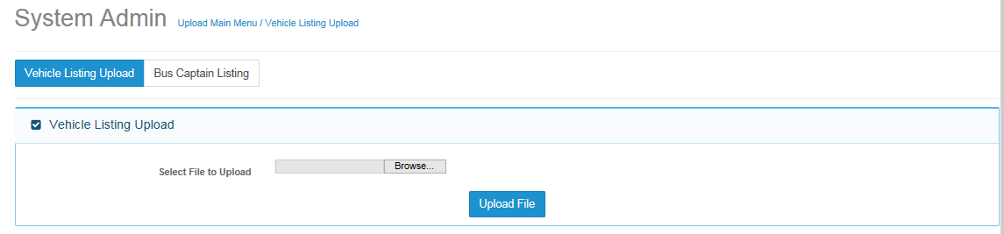

* Click on  button to view Vehicle listing upload screen.
* First section will be interface to upload file.

## Browse Screen

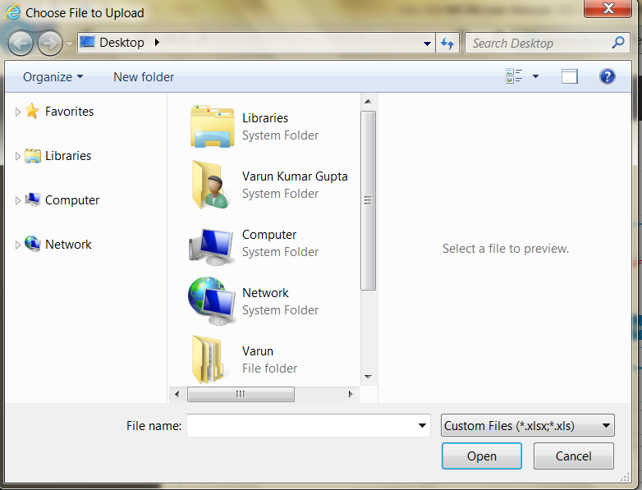

* Click  button to search for file to be uploaded.

For these functions, please include –

1. The outcome when user attach the file and click Upload File button
2. What are the file validations done before upload file is accepted and in processing the file, what are the validations
3. Errors that system will handle and the corresponding messages. What should the User do for each error encountered.

d. Is there a message that uploading is in progress and when completed? How does the system handle concurrency issue?

e. What does the user do in respect of failed cases – list down the steps

f. specify the outcome of this function and the Status – Complete, ? for failed file and ? for partially successful file

### Search criteria section

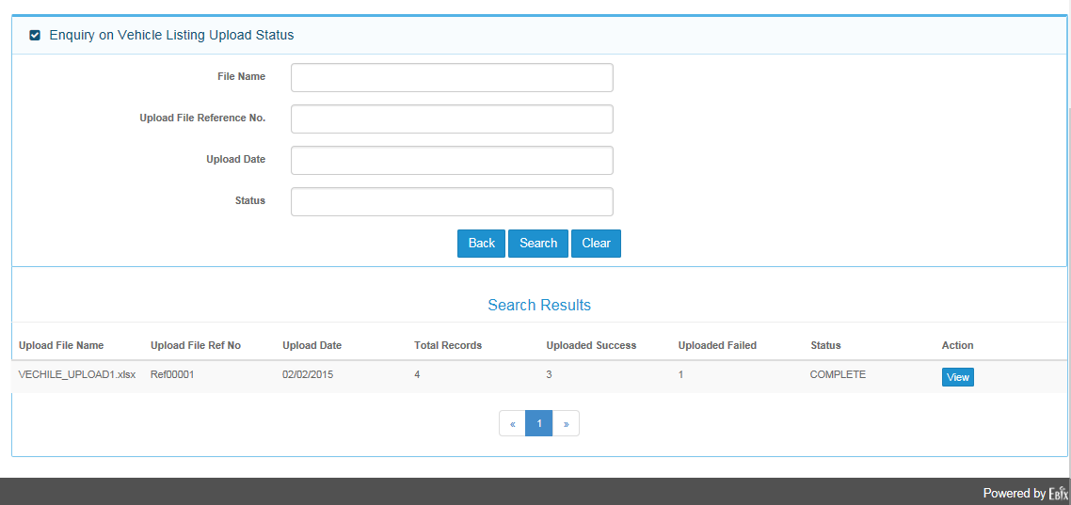

* Enter either File name, Upload File reference No. , upload Date or Status to search file .
* Click  to view search results
* Click  to go back to vehicle upload listing main screen
* Click  to clear inserted content
* Search Result section will show by default oldest created record
* By clicking on left and right aero  user can also navigate search result screen.

## Bus Captain Listing Screen

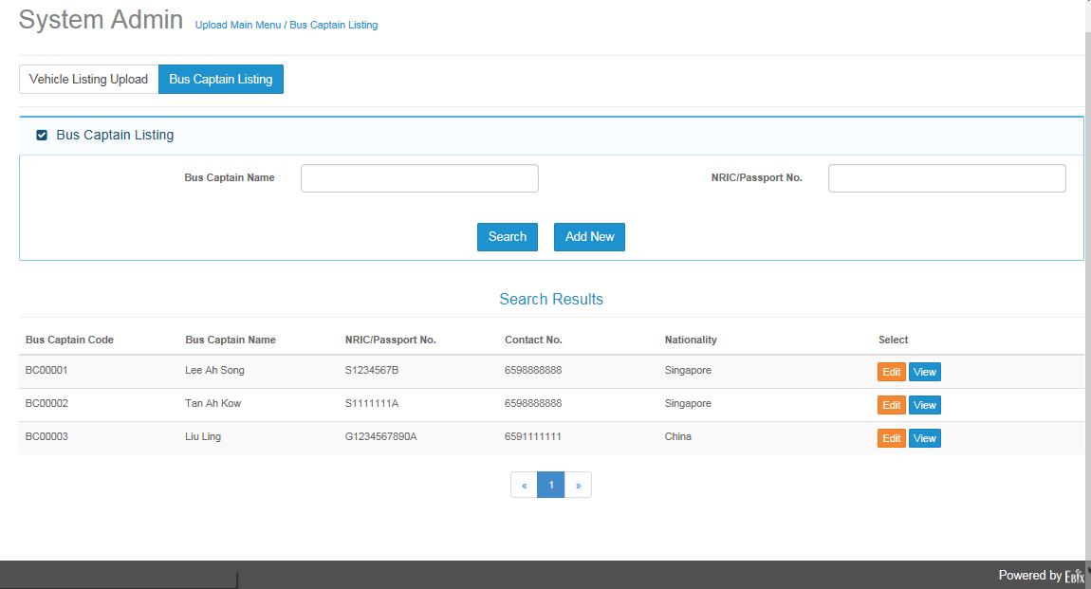

* Bus Captain Listing is having Search criteria , Search Results
* On search criteria fill either “Bus captain name or NRIC/Passport No. “
* Click  button for searching existed record.
* Click  button to add bus captain record.
* Click  button to edit selected record.
* Click  button to view selected record.

### Add Screen

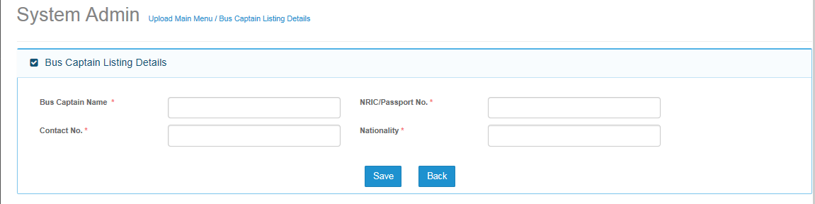

* Add Screen will add bus captain record in application

|  |  |
| --- | --- |
| **Field Name** | **Description** |
| Bus Captain Name | * Enter name of Bus Captain. |
| NRIC/Passport No. | * Enter passport no. or NRIC no of bus captain |
| Contact no. | * Enter Contact no. of bus captain |
| Nationality | * Enter Nationality of bus captain |

Please include any validation rules – for example, duplicate NRIC/Passport No.? Contact No.? Contact No. must start with a specific numeric number for mobile phones?

Please include all system messages displayed and purpose.

# Department Master Creation

## Description:

Department Master is use to Create department of organization.

## Screen shot of Add Screen

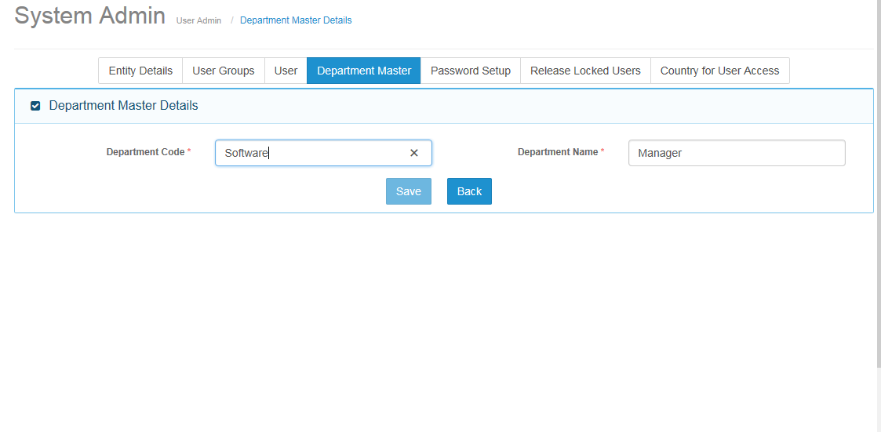

## Dependent Screens

1. Add User screen: For User creation Department is mandatory.

# Insurer Master

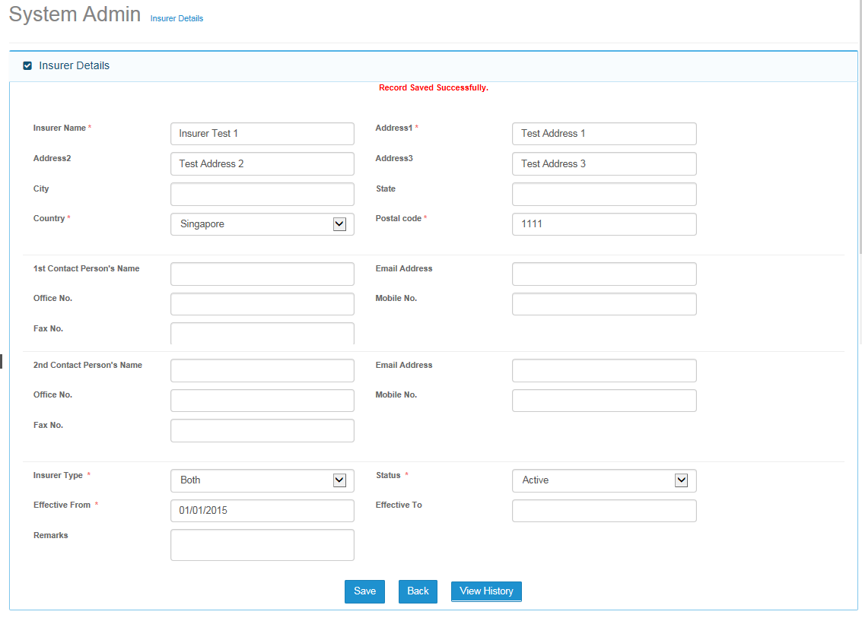

# Surveyor Master

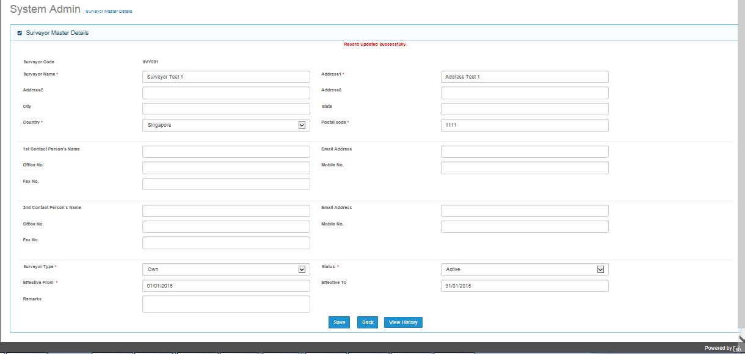

# Lawyer Master

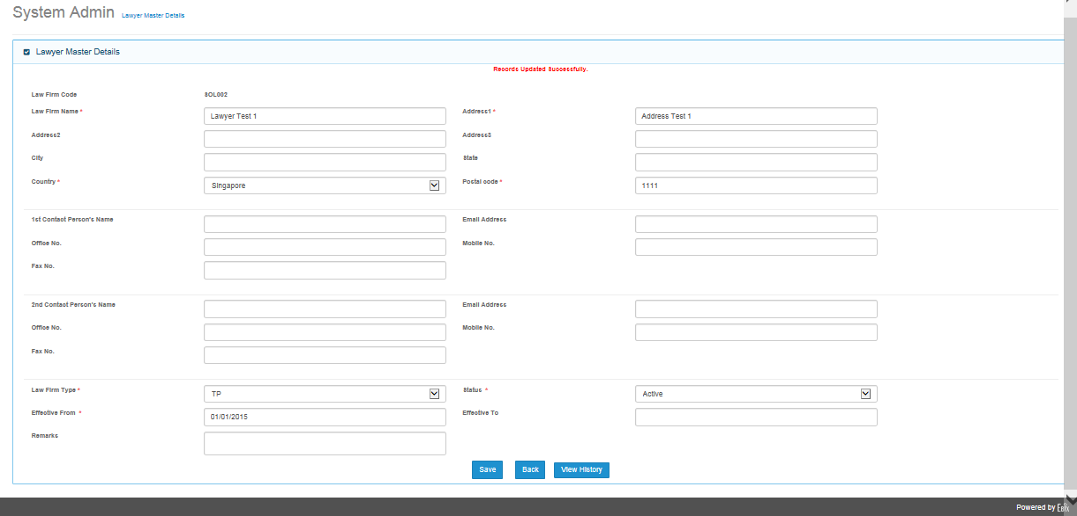

# Workshop Master

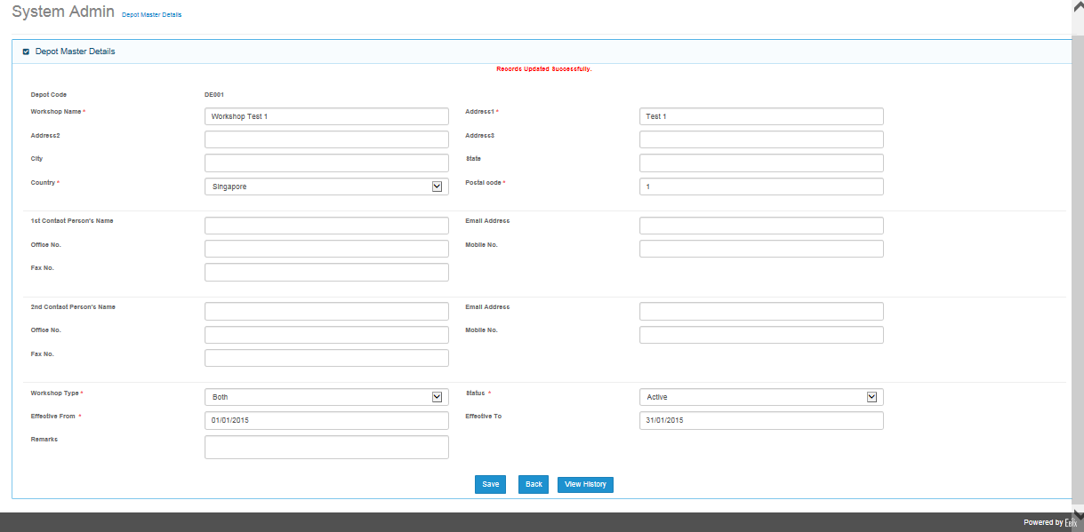

# Adjuster Master

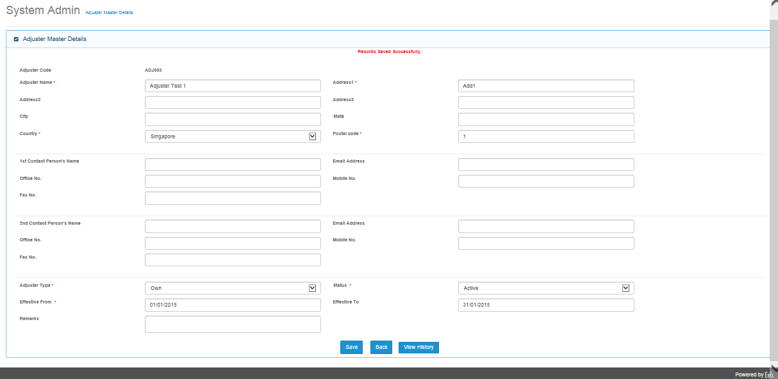

# Hospital Master

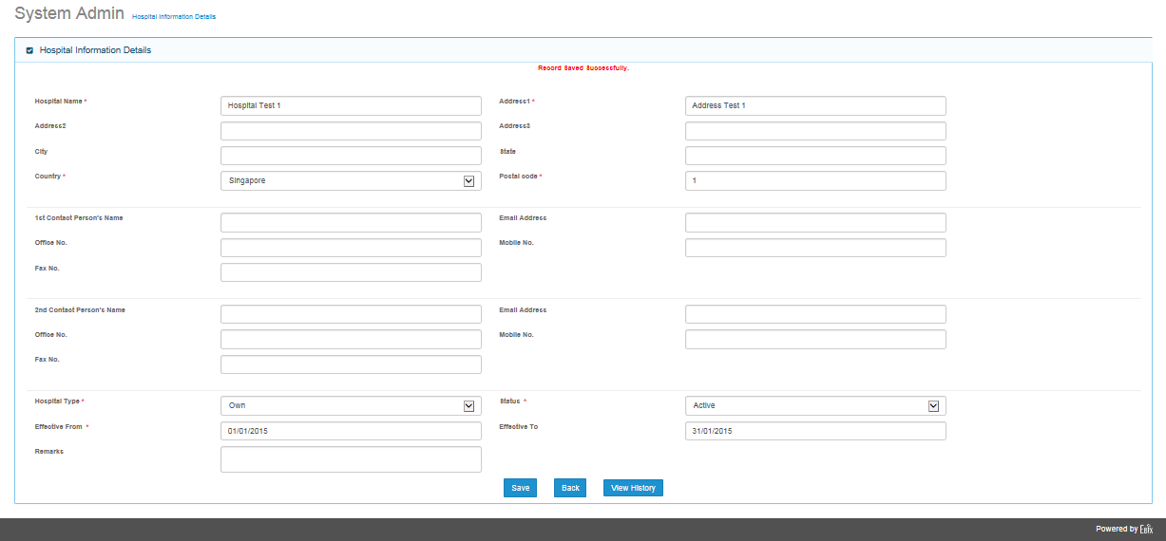

# Organization

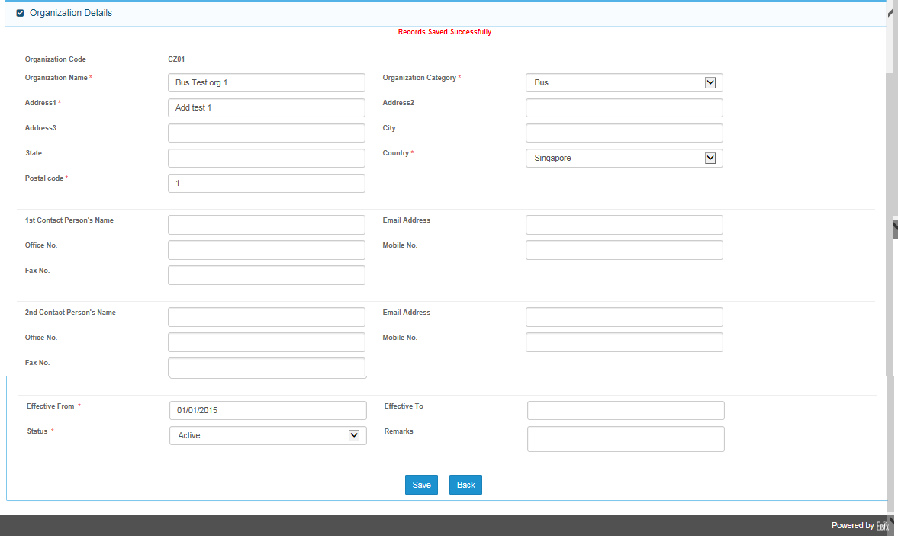

# Deductible Master

